SMART WATER SYSTEM

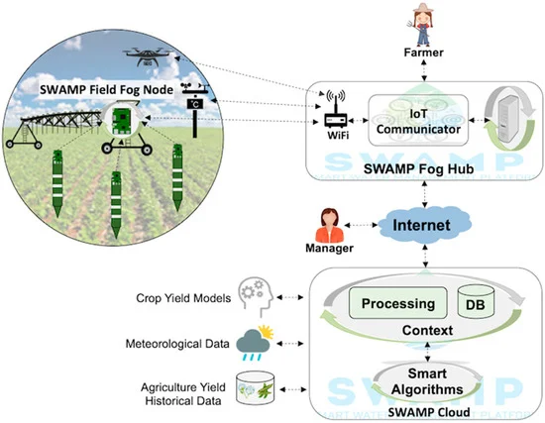

SWAMP Baseline Scenario including SWAMP Cloud and SWAMP Fog (further organized into SWAMP Fog Hub and SWAMP Field Fog Node).

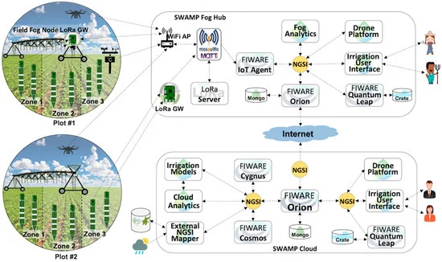

MATOPIBA Scenario represented in the FIWARE-based SWAMP Platform

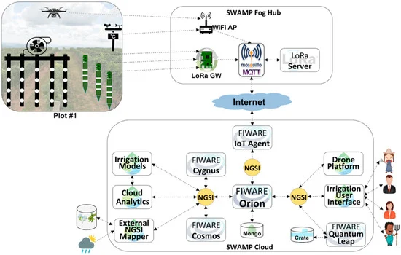

Guaspari Scenario represented in the FIWARE-based SWAMP Platform.

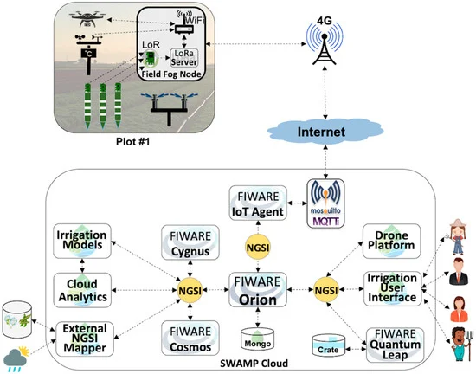

Intercrop Scenario represented in the FIWARE-based SWAMP Platform.

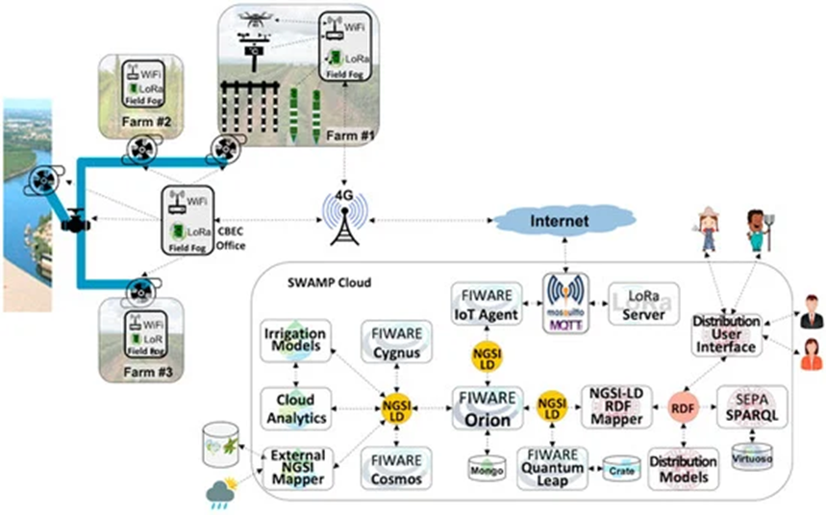

CBEC Scenario represented in the FIWARE-SEPA-based SWAMP Platform